

**Lesson 2: Main Colour Commands**

**Summary:**

|  |  |
| --- | --- |
| **Code Instruction** | **What it does** |
| **t.color(‘green’)** | **Set the line color to be green** |
| **t.fillcolor(‘gold’)** | **Set fill color to be gold** |
| **t.begin_fill()** | **Start filling a shape** |
| **t.end_fill()** | **Stop filling a shape** |
| **t.color(‘green’,’red’)** | **Set the line color to be green and shape color to be red** |
| **t.penup()** | **Stop the turtle from drawing** |
| **t.pendown()** | **Start the turtle drawing again** |
| **t=turtle.Tutrtle(‘turtle’)** | **Set turtle shape as turtle\*\*\*** |

***For kids who use trinket editor instead one line it is necessary to insert two lines

t=turtle.Turtle()

t.shape(‘turtle’)

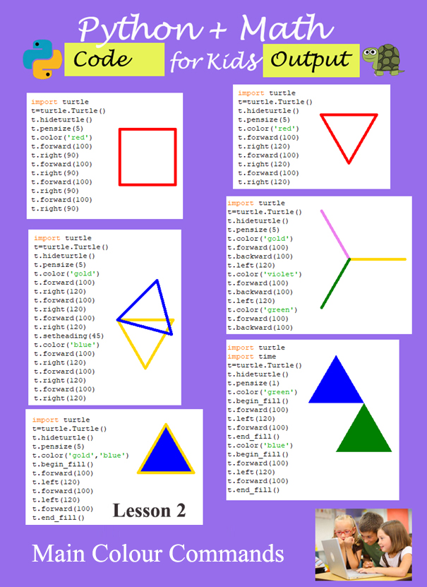

1. **Example #1** (Draw line)

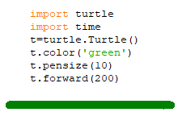

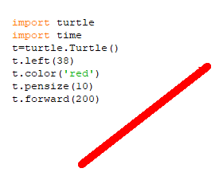

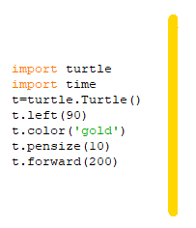

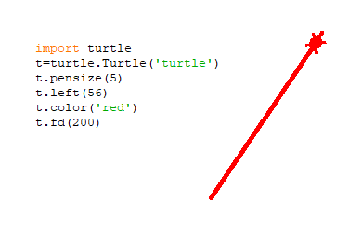

1. **Example #2** (Draw a few lines)

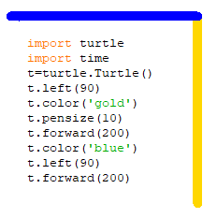

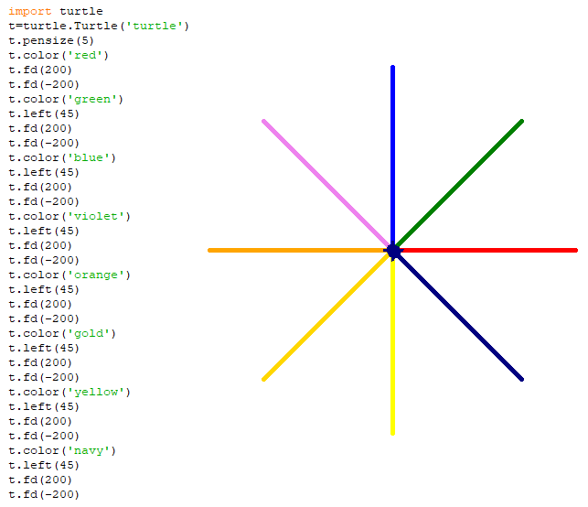

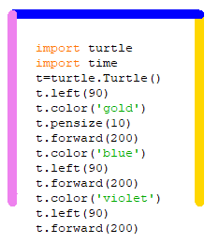

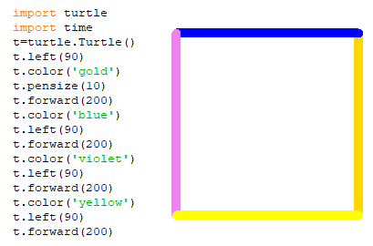

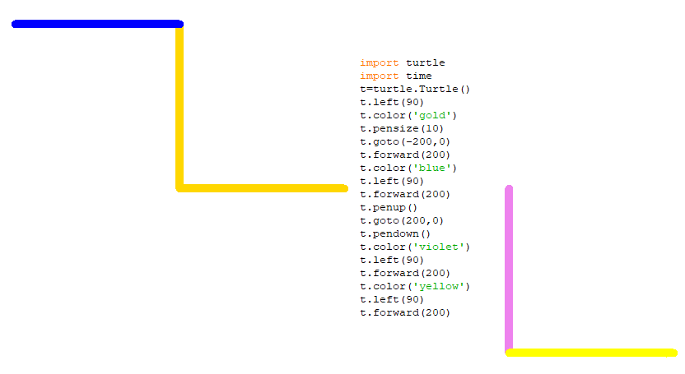

1. **Example #3**(Colour filled geometric shapes)

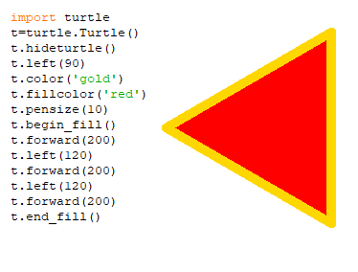

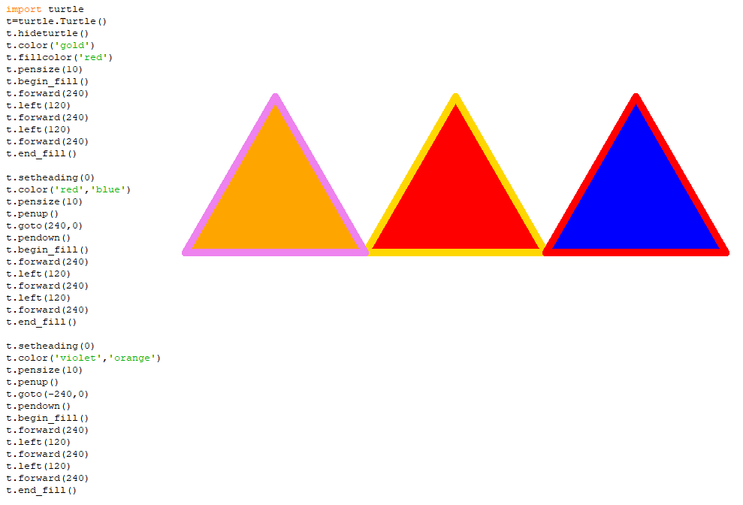

1. **Example #4**(Colour star)

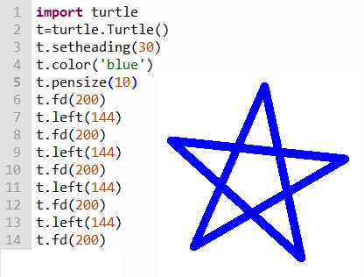

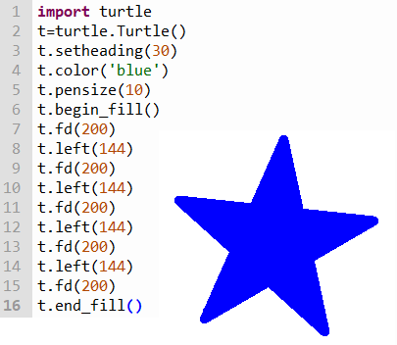

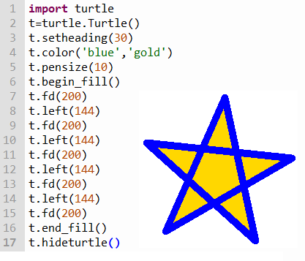

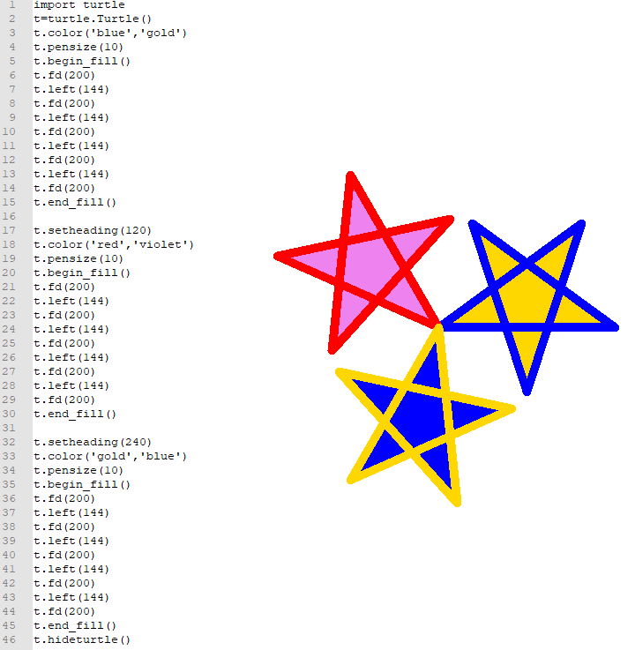

1. **Example #5**(Russian Flag)

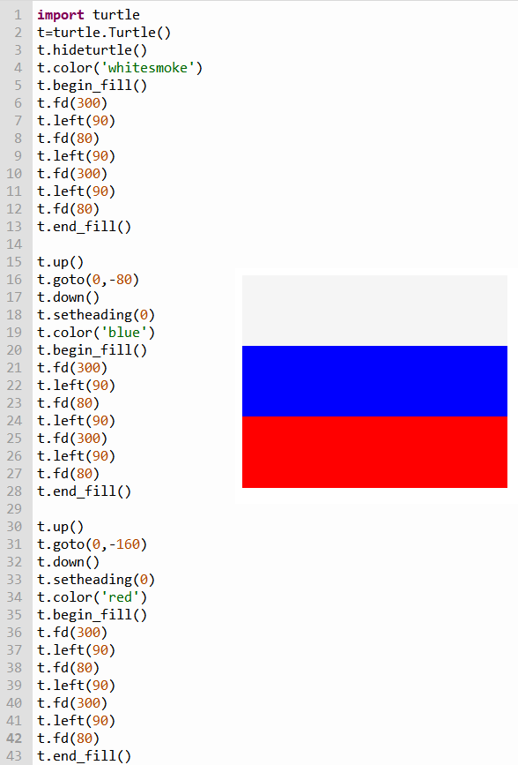

1. **Example #6** (Flag of France)

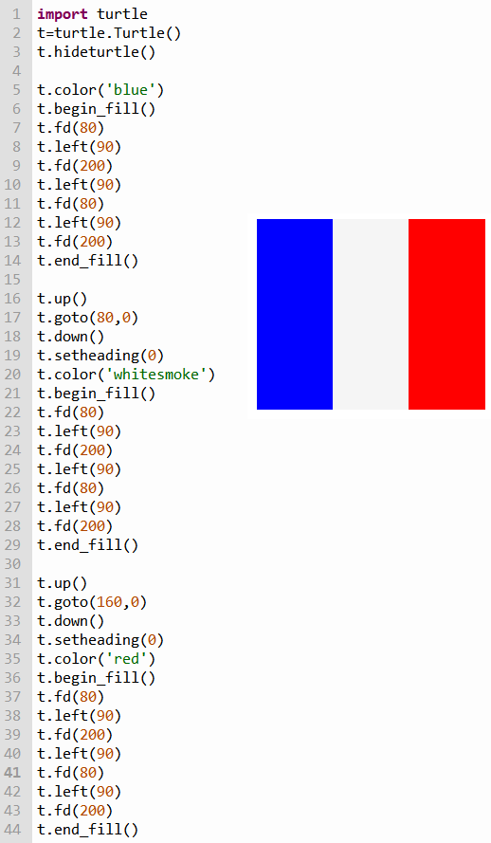

Challenges: write codes to create the following geometry shapes:

1. Expected output



1. Expected output

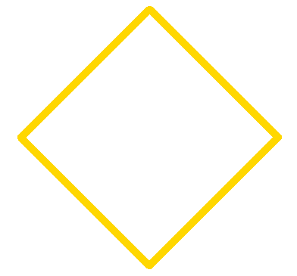

1. Expected output

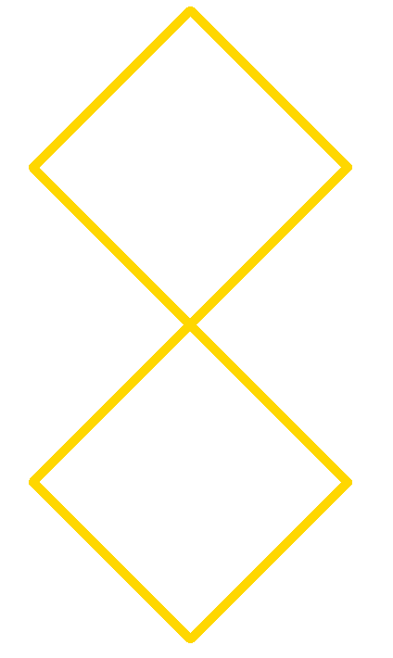

1. Expected output

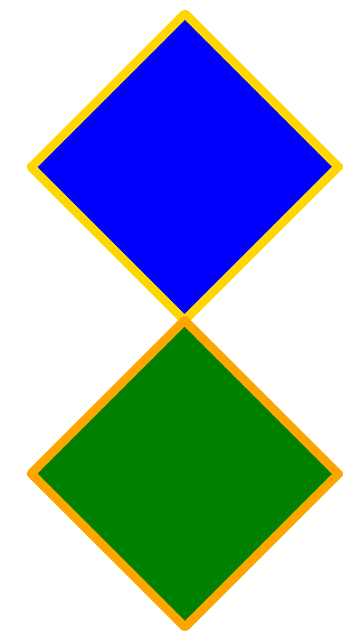

1. Expected output (Flag of Romania)

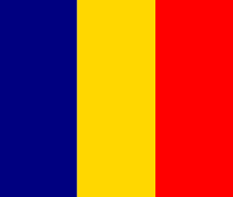

1. Expected output (Flag of Italy)

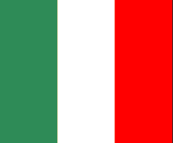

**Colour List**

